[1]

**Vertical interaction between dust particles confined in a glass box in a complex plasma**

Jie Kong, Ke Qiao, Jorge Carmona-Reyes, Angela Douglass, Zhuanhao Zhang, Lorin S. Matthews, Truell W. Hyde

*Abstract*— In this experiment, falling particle trajectories within and without a glass box placed on the lower electrode in a GEC reference cell were recorded and analyzed and the electrostatic forces exerted on the dust particles measured and compared. Experimental results show that for particles falling in a complex plasma with no glass box, only a single force balance point (i.e., the position where the gravitational force is balanced by the electrostatic force) exists in the vertical direction, while for particles falling inside a glass box, this force balance spans an extended vertical range.

*Index Terms*— Complex Plasma, Diagnostics, Plasma Sheath, Interaction Force.

# INTRODUCTION

A

nisotropic 2D dust clusters formed within a complex plasma system and confined by a biharmonic potential in the horizontal plane (i.e., perpendicular to the gravitational force) have recently been investigated both experimentally and numerically. By varying the ratio of the overall confinement in the different directions, also called the anisotropy parameter, transitions from a 1D to a 2D zigzag configuration have been numerically predicted to occur and experimentally observed [1 – 5]. The interaction of the charged grains with the plasma as characterized by the screening parameter, κ, and the number of particles within the system have been shown to play important roles in this transition.

More recently, similar structural transitions have been observed for clusters oriented in the vertical direction (i.e., parallel to the gravitational force) of a complex plasma system [6]. In this case, a glass box is placed on the lower, powered electrode of a Gaseous Electronics Conference (GEC) rf reference cell in order to provide radial confinement. The strength of this confinement is determined in large part by the rf power, which in turn determines the electrostaic force produced by each of the walls comprising the glass box. Under strong radial confinement, dust particles within the box can form extended vertical strings. In this case as opposed to horizontally aligned dust cluster systems, where reducing the confinement leads to a 1D to 2D zigzag transition, reducing the radial confinement can create a zigzag transition from a 1D string to a 2D planar structure, with further reduction of the confinement allowing for the development of additional 3D vertically aligned dust structures [7]. In order to understand these transitions, the corresponding anisotropy parameter must first be determined (here are horizontal and vertical resonance frequencies respectively).

A major complicating factor in determining the anisotropy parameter is that by default, vertically aligned dust particle chains span a large portion of the sheath above the powered electrode. Since the plasma conditions, particle charge and electric field have all been shown to change with height above the electrode, this creates an interesting dilemma.

Recently, it has been shown that free-falling dust particles within a complex plasma can act as in-situ probes, providing a minimally perturbative diagnostic for the measurement of the electrostatic force distribution [8]. This technique is particularly useful for measuring these parameters within a glass box, as the electric potential within this structure is not yet well-understood.

As such, this experiment measures the trajectories of falling dust particles in order to determine the electrostatic force distribution above the lower powered electrode in a GEC reference cell both inside and outside a glass box. Section II provides a short description of the experimental method and analysis technique. In Section III, a discussion of the data collected is given with the results and conclusions drawn from these data provided in Section IV.

# Experiment and analysis

The experiment discussed here was conducted within one of two modified GEC rf reference cells located in the Center for Astrophysics, Space Physics & Engineering Research (CASPER) lab at Baylor University [7]. The cell used contains a grounded, upper electrode and a powered, lower electrode separated by 2.54 cm, capacitively coupled to the system and driven at 13.56 MHz. An open-ended glass box, having dimensions of 12.5 mm × 10.5 mm (height × width) and a wall thickness of 2 mm, was placed on top of the powered lower electrode in order to provide horizontal confinement to the dust particles. All experiments were performed in an Argon plasma at 16 Pa with the amplitude of the rf voltage varied between 240 and 520 mV (Fig 1).

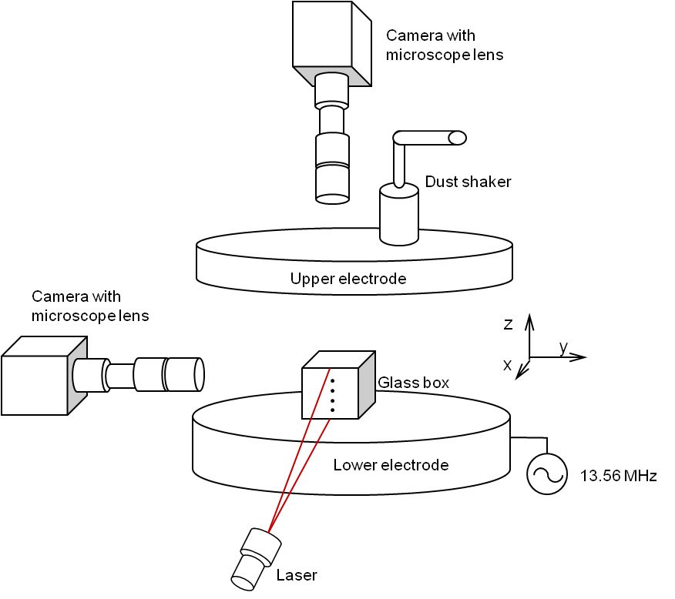

Fig 1. Experimental setup. The open-ended glass box shown has dimensions of 12.5 mm × 10.5 mm (height × width) and a wall thickness of 2mm.

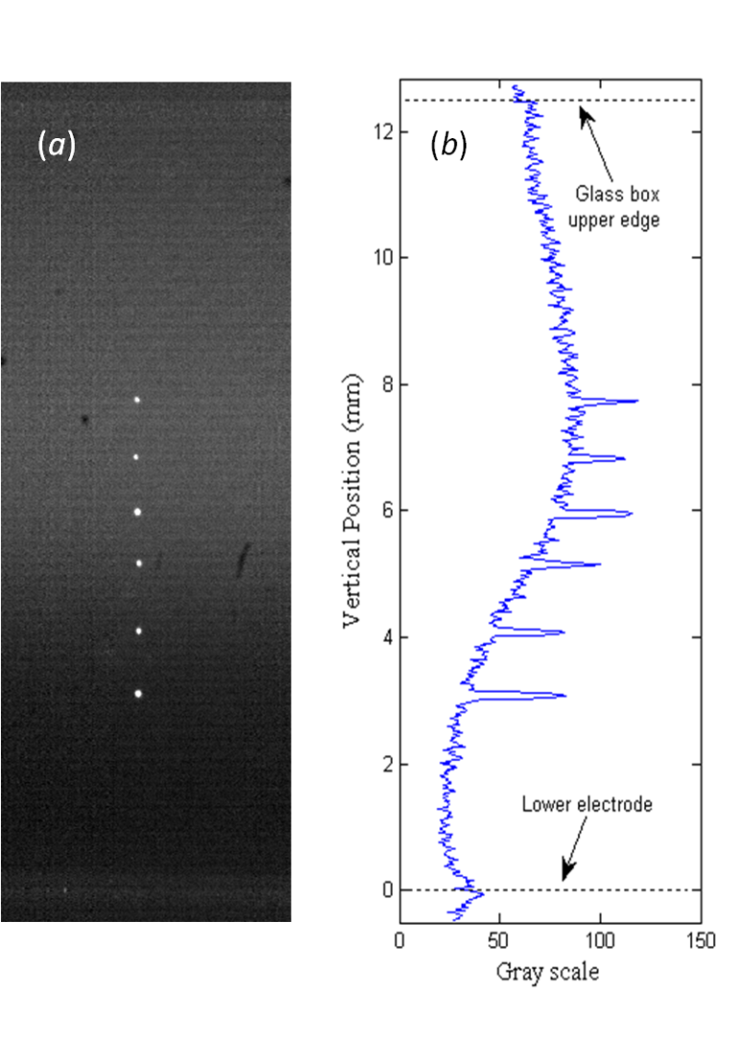

Fig 2. (a) A 1D vertical dust chain formed of 8.89 μm MF dust particles inside the glass box described within the text. (b) A gray scale intensity distribution showing the particles located at the ends of the chain are approximately 3 and 8 mm above the lower powered electrode, respectively. In the above, the Argon background gas was held at 16 Pa under 2.5 W rf power.

Melamine formaldehyde dust particles, 8.89 ± 0.09 μm in diameter, were introduced via shakers mounted above the hollow upper electrode into an Argon plasma having a neutral pressure of 16 Pa (Fig 2). A single dust particle chain was formed at the center of the glass box by first introducing the dust particles into the box at a rf power of 4 W. At this power, a turbulent dust cloud forms naturally inside the box; slowly decreasing the rf power from 4 to 2.5 W then forms a single vertical dust particle chain at the center of the box as shown in Fig 3.

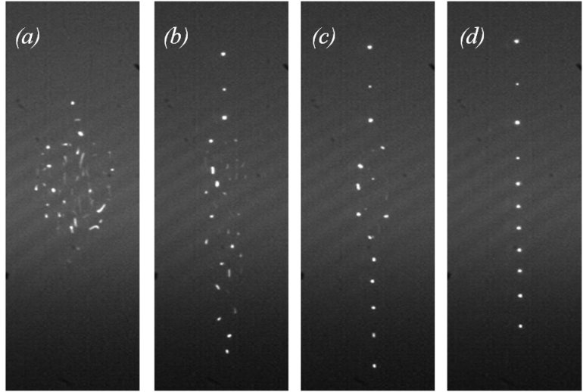

Fig 3. Formation of a single particle chain inside a glass box placed on the lower electrode by decreasing the rf power from (a) 4 W, to (d) 2.5 W.

In order to better understand the physics behind this process, the electrostatic force profile inside the glass box must first be measured. To insure minimal perturbation to the dust-plasma system, this profile was determined by mapping the trajectories of single falling dust particles, recorded using a side-mounted, high-speed CCD (Photron) camera operating at a speed of 500 frames per second (fps). The electrostatic force acting on the dust particles in the vertical direction was determined by analyzing the relationship between particle trajectories and the vertical component of the total force exerted on them,  [8].

The vertical force balance for a falling dust particle under these conditions can be written as



where *md* and *Qd* are the particle’s mass and charge, respectively, *E* is the magnitude of the vertical electric field, *β* is the neutral drag coefficient, and *g* is the gravitational acceleration. Under the conditions examined, the ion drag force is a minimum of two orders of magnitude smaller than the electric force inside the glass box [9] and will therefore be ignored in Eq (1).

Comparing the trajectories for dust particles falling inside the glass box to trajectories for dust particles falling through a complex plasma with no glass box allows the effect that the box has on the system to be isolated. Fig 4 shows representative graphs for the dust particle trajectory data collected in this study. Plots show vertical versus horizontal positions and vertical positions versus time for particles falling through a complex plasma with no glass box in the system (4a, 4c), and inside a glass box within a dusty plasma system (4b, 4d).

Fig 4a.eps

Fig 4b.eps

Fig 4c.eps

Fig 4d.eps

Fig 4. (a) Dust particle trajectories for a particle falling through a plasma with no glass box in the system, and (b) falling inside a glass box within a dusty plasma system. (c) Vertical particle position versus time for a particle falling through a plasma with no glass box in the system, and (d) inside a glass box within the dusty plasma system. The argon pressure for all cases is 16 Pa and the rf power is 2.5 W. The estimated uncertainty on the vertical position measurement is < ±50 μm.

Comparing Figs 4a and 4b, it can be seen that for identical pressures and powers, dust particles inside the glass box fall directly through the system before impacting the lower electrode while without the glass box, particle undergo damped oscillations, before reaching an equilibrium height. As can be seen from the figure, both cases show small horizontal drift. For the case without a box, the drift is most probably caused in our case by irregularities in the horizontal confinement force produced by the 1mm deep, 2.54 cm diameter cutout on the lower electrode. For the case with a box, the horizontal displacement is likely the result of the horizontal component of the electrostatic force from the glass walls as it ‘recovers’ the particle to the midline (i.e., its equilibrium position) after it has been dropped into the system.

Examining the vertical motion of the particle with respect to time as shown in Figs 4c and 4d, the vertical acceleration and velocity of the dust particle can now be derived once the drag coefficient, β, is known.

For the case of a plasma with no glass box, the drag coefficient, β, can be derived using Eq 1, assuming underdamped motion

 .

In this case, *a0, β, ω0, φ0* and *z0* can be determined experimentally through fitting the trajectory data collected. In order to satisfy the small displacement condition required for linear oscillation, only data between 0.15 s < t < 0.35 s, as shown in Fig 4c, were used in Eq 2. With respect to the neutral drag force, the horizontal (with a box) and vertical (without a box) components of the particles’ motion both exhibit damped oscillations. Analysis of the vertical oscillatory motion (without the box) yields a value of β = 12.4 s-1. Measured values of the in-box horizontal oscillatory motion provide values of β varying between 8 and 16, but produce very little difference in the overall resulting fit. Based on this, a value for β of 12.4 s-1 was chosen for analysis of the motion within the box. This value has the added advantage that it matches previous experimental results. With the assumption the drag coefficient is determined primarily by the neutral gas pressure, this value of beta was also be used for particles falling inside the glass box.

With beta determined, the normalized electrostatic forces, , can now be derived for both cases, using Eq (1). These results are shown in Fig 5.

As shown in Fig 5c, the difference between the force from the electric field for the two cases can be interpreted as the contribution to the electric field provided by the glass box. As shown for a particle falling through a plasma with no glass box, a zero point occurs 4.6 mm above the lower electrode; above this point, the force on the particle is positive (i. e., directed opposite the gravitational field), while below it, the force is negative (i. e., directed downward).

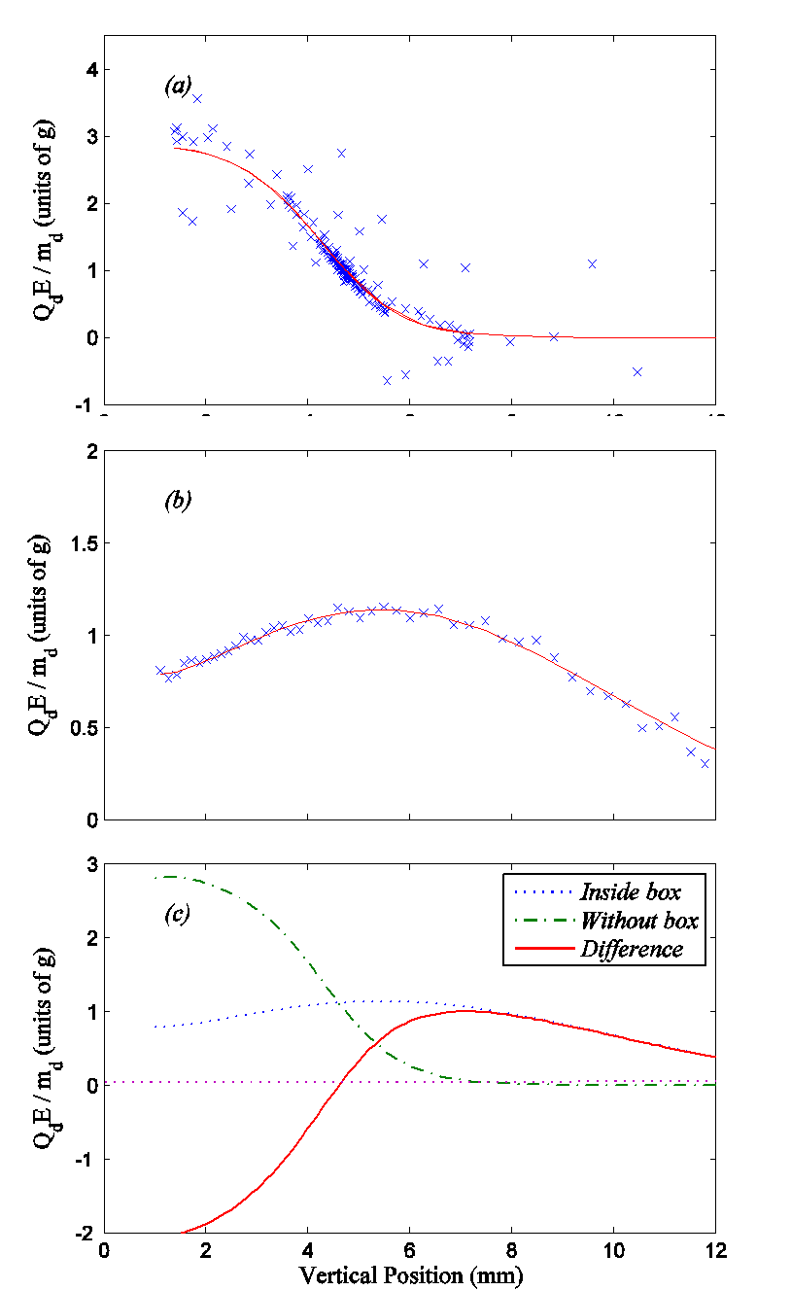

Fig 5. Normalized vertical electrostatic force distribution (a) for a system with no glass box, (b) a system with a glass box, and (c) the difference between these two cases, which represents the contribution provided by the glass box to the overall electrostatic force exerted on the dust particle. (g = 9.8 m / s2).

# Discussion

According to the manufacturer, the dust particle diameter may vary by up to 2%. Assuming charge is evenly distributed over the surface of the dust grain,, where  is the surface charge density and is the dust particle radius. In this case, the normalized force can be written as , whereis a constant. Any error should thus be of the same order of magnitude as that claimed by the manufacturer.

It has also been reported that the mass of a dust particle within a complex plasma is not constant, where this effect is most pronounced during the first five hours the dust particle is in the plasma [10]. In this experiment the dust particle falls through the plasma in less than one second. Before being released, the dust particle is held (at least overnight in high vacuum about 5×10-7 mTorr) within a dust dropper, which is itself a shielded environment. The plasma environment through which the dust particle is dropped is also held at a much lower power than that used in [10]. As such, this phenomenon creates an ignorable uncertainty.

Therefore the uncertainty in the normalized force, as shown in Fig 5, is of the same order of magnitude as that provided by the manufacturer for the dust size distribution. This uncertaintly is much less than the overall uncertainty due to the vertical position measurement, which is estimated < ±50μm, and is therefore ignored.

In order to levitate a dust particle above the powered electrode within an experimental complex plasma system located in a gravitational field, the minimum normalized vertical electrostatic force on the particle must be at least 1g (where g = 9.8 m / s2, is the gravitational acceleration). In the sheath region with no glass box present, the 1g point is located 4.6 mm above the lower electrode, coinciding with the vertical equilibrium position shown in Fig 5c. As expected, closer to the lower electrode, the force due to the electric field increases rapidly in an almost linear fashion to more than 2g, while further away, it slowly decreases. Interestingly inside the glass box, the normalized electrostatic force exerted on the dust particle remains slightly greater than 1g across the region located between 3 and 8 mm above the lower electrode. Within this region, any small additional downward force breaks the overall force balance; outside this region, the electrostatic force is smaller than the gravitational force. As a result, a dust particle falls through the plasma to the lower electrode when inside the glass box but exhibits under-damped motion before reaching equilibrium when in a plasma with no glass box. (See Figs 4a and 4b, respectively.)

The difference, as shown in Fig 5c, between the normalized vertical electrostatic force in a plasma with a glass box and one with no glass box present is due to the surface charge collected on each pane of the box. Within a plasma, each of the glass surfaces making up the box collects high energy electrons and (relatively) low energy ions, resulting in the accumulation of an overall negative surface charge. Due to plasma shielding, this surface charge exerts a Yukawa-type force on the particles within the box. In this case, decreasing the rf driving power lowers the overall ionization rate of the plasma, decreasing the plasma density and concurrently increasing the screening length. This results in an increase in the interaction between the charged glass surfaces and the dust particles [9] providing a horizontal (or radial) force component, which pushes the dust particles toward the center of the glass box while producing a vertical component having the distribution shown in Fig 5c.

Finally, it is interesting to note that an extended vertical region, where the normalized electrostatic force is approximately equal to 1g, exists within the glass box. As shown in Fig 2b, a gray scale intensity distribution shows the lowest particle in the vertical chain formed inside the glass box to be located 3 mm above the lower electrode with the highest particle approximately 8 mm above the lower electrode. This provides a direct measurement of the overall extension of the vertical force region formed inside the box and delineates where the vertical forces acting on the particles are in balance (See Fig 5b). This region provides the force balance necessary for the formation of extended particle chains in the vertical direction. On the other hand for a plasma with no glass box present, the narrow vertical regime located approximately 4.6 mm above the lower electrode provides the only equilibrium region in which a single dust particle can reside (or horizontal layer of dust particles can easily form, see Fig 5a).

# Conclusions

By tracing the trajectories of dust particles falling through the plasma sheath residing within a complex plasma system with no glass box present and a complex plasma system with a glass box present, the vertical distribution of the electrostatic force on the particles has been determined.

The primary difference found between these two systems (i.e., without and with the glass box) is that for particles located within a plasma outside the glass box, the force equilibrium structure produced consists of a single equilibrium point located approximately 4.6 mm above the lower powered electrode. For particles located inside a glass box, the vertical component of the electrostatic force very nearly equals the gravitational force over an extended vertical region, allowing the formation of extended dust particle chains in a gravitational environment. This force due to the electric field is due to a combination of the sheath electric field provided by the lower powered electrode and the electric field created by the surface charging of the glass walls comprising the box. The corresponding extended vertical force balance region is approximately 5 mm in length for a plasma created under the conditions of this experiment, and a dust string can span this entire vertical distance. The interparticle distances within this chain are thus an indication of the interparticles forces. These distances change with changing plasma conditions (rf power, gas pressure) and thus serve to probe the plasma conditions in the vertical direction. This phenomena is still under investigation. The effect that the extended force balance region has on the corresponding anisotropy parameter will also be discussed in an upcoming paper.

References

1. A. Melzer, “Zigzag transition of finite dust clusters”, Phys. Rev. E, 73, 056404, 2006.
2. T.E. Sheridan, “Discontinuous structure transition in a Debye cluster”, Phys. Plasmas, 19, 057302, 2012.
3. L. Candido, J. Rino, N. Studart, and F. M. Peeters, “The structure and spectrum of the anisotropically confined two-dimensional Yukawa system”, J. Phys.: Condens. Matter, 10, 11627 – 11644, 1998.
4. T. Kamimura, O. Ishihara, “Coulomb double helical structure”, Phys. Rev. E, 85, 016406, 2012.
5. T. E. Sheridan, “Center of mass and breathing mode oscillations in a small complex plasmas disks”, Phys. Rev. E, 72, 026405 2005.
6. T. W. Hyde, J. Kong, M. Chen, A. Douglass, B. Harris, K, Qiao, Z. Zhang, V. Land, “Collective phenomena in dusty plasma”, Proceeding of 13th workshop on the physics of dusty plasma, Waco, Texas, USA, May 2012.
7. J. Kong, T. W. Hyde,L. Matthews, K. Qiao, Z. Zhang, and A. Douglass, “One-dimensional vertical dust strings in a glass box”, Phys. Rev. E, 84, 016411, 2011.
8. Z. Zhang, K. Qiao, J. Kong, L. Matthews, and T. Hyde, “Simple method to measure the interaction potential of dielectric grains in a dusty plasma”, Phys. Rev. E, 82, 036401, 2010.
9. O. Arp, D. Block, M. Klindworth, and A. Piel, “Confinement of Coulomb balls”, Phys. Plasmas, 12, 122102, 2005.
10. J. Carstensen, H. Jung, F. Greiner, and A. Piel, “Mass change of microparticles in a plasma observed by a phase-resolved resonance method”, Phys. Plasmas, 18, 033701, 2011.

1. Manuscript received July 31, 2012.

   J. Kong, K. Qiao, J. Carmona-Reyes, A. Douglass, Z. Zhang, L. Matthews, and T. Hyde (corresponding author) are with the Center for Astrophysics, Space Physics & Engineering Research, Baylor University, One Bear Place #97310, Waco, TX. 76798 USA.(phone: 254-710-3763, fax: 254-710-7309, e-mail: [J_Kong@baylor.edu](mailto:J_Kong@baylor.edu), [Truell_Hyde@baylor.edu](mailto:Truell_Hyde@baylor.edu)).